Project Design Phase-II
Data Flow Diagram & User Stories

Date | 27-12-2025
Team ID | SmartBridge – MERN stack batch 5497
Project Name | Bago (E-Commerce)

Data Flow Diagrams:
A Data Flow Diagram (DFD) illustrates how data moves within the E-Commerce platform. It captures how users (customers and administrators) interact with the system, how information flows between different functional components such as product management, cart, orders, and authentication, and where data is stored, including user details, product data, orders, and reviews.
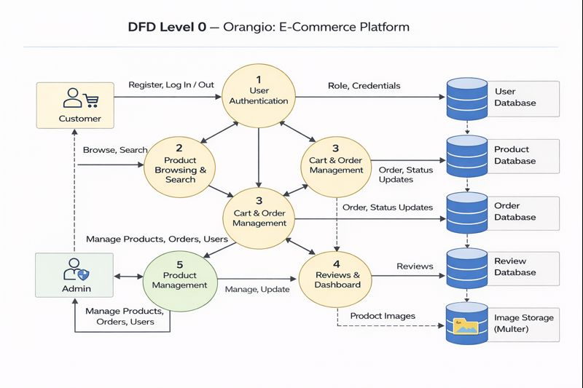

User Stories – Orangio
User Story Table – Orangio
User Type | Functional Requirement (Epic) | User Story / Task | Acceptance Criteria | Priority | Release
Customer | User Registration & Login | As a customer, I can register and log in securely to the platform. | Customer account is created and user is redirected to the customer dashboard after login. | High | Sprint-1
Customer | Product Browsing & Search | As a customer, I can browse and search products by name or category. | Relevant products are displayed based on search input or category selection. | High | Sprint-1
Customer | Product Details | As a customer, I can view detailed information about a product. | Product page shows images, price, description, and availability. | High | Sprint-1
Customer | Cart Management | As a customer, I can add products to the cart and update quantities. | Cart updates correctly and reflects selected products. | Medium | Sprint-2
Customer | Order Placement | As a customer, I can place an order by providing delivery details. | Order is saved successfully and visible in customer order history. | High | Sprint-1
Customer | Review System | As a customer, I can submit ratings and reviews for purchased products. | Review is saved and visible on the product page. | High | Sprint-1
Customer | Profile Management | As a customer, I can update my profile details such as address and contact number. | Profile updates are saved successfully. | Medium | Sprint-2
Admin | Product Management | As an admin, I can add, update, or remove products from the system. | Product changes reflect immediately on the platform. | Medium | Sprint-1
Doctor | Order Management | As an admin, I can view and manage all customer orders. | Order list and order status are visible to admin. | High | Sprint-1
Admin | Doctor Approval | As an admin, I can approve or reject doctor registrations. | Only approved doctors appear in public listings. | High | Sprint-1
Admin | Doctor Management | As an admin, I can remove doctors from the system if required. | Doctor is removed and no longer visible to users. | High | Sprint-2
Admin | Review Monitoring | As an admin, I can monitor doctor reviews to ensure platform quality. | Reviews are visible to admin for moderation. | Medium | Sprint-2
User | Logout | As a logged-in user, I can securely log out of the application. | Session is cleared and user is redirected to home page. | Medium | Sprint-1

